PRODUCER CONSUMER PROBLEM
#include <stdio.h>
#include <stdlib.h>
#include <pthread.h>
#include <semaphore.h>
#include <unistd.h>

#define BUFFER_SIZE 5

int buffer[BUFFER_SIZE];
int in = 0;
int out = 0;

sem_t empty;
sem_t full;
pthread_mutex_t mutex;

void *producer(void *arg) {
int item;
for (int i = 0; i < 10; i++) {
item = rand() % 100;
sem_wait(&empty);
pthread_mutex_lock(&mutex);

buffer[in] = item;
printf("Produced %d at %d\n", item, in);
in = (in + 1) % BUFFER_SIZE;

pthread_mutex_unlock(&mutex);
sem_post(&full);
sleep(1);
}
return NULL;
}

void *consumer(void *arg) {
int item;
for (int i = 0; i < 10; i++) {
sem_wait(&full);
pthread_mutex_lock(&mutex);

item = buffer[out];
printf("Consumed %d from %d\n", item, out);
out = (out + 1) % BUFFER_SIZE;

pthread_mutex_unlock(&mutex);
sem_post(&empty);
sleep(2);
}
return NULL;
}

int main() {
pthread_t prod, cons;

sem_init(&empty, 0, BUFFER_SIZE);
sem_init(&full, 0, 0);
pthread_mutex_init(&mutex, NULL);

pthread_create(&prod, NULL, producer, NULL);
pthread_create(&cons, NULL, consumer, NULL);

pthread_join(prod, NULL);
pthread_join(cons, NULL);

sem_destroy(&empty);
sem_destroy(&full);
pthread_mutex_destroy(&mutex);

return 0;
}
OUTPUT:
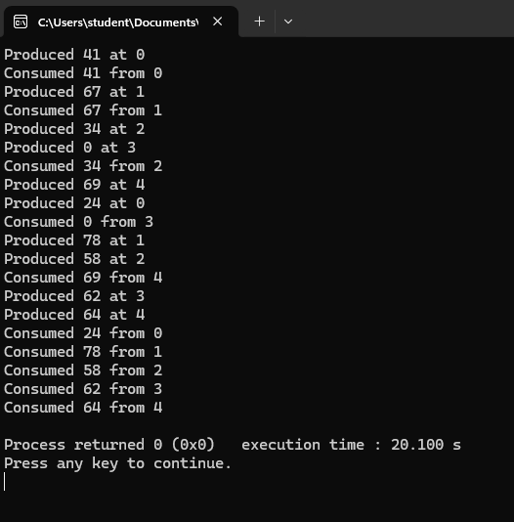

OBSERVATION:

